**Project Report: Predicting Liver Cirrhosis Using Machine Learning**

**Title**

**Revolutionizing Liver Care: Predicting Liver Cirrhosis Using Advanced Machine Learning Techniques**

**Problem Statement**

Liver cirrhosis is a progressive liver disease leading to liver failure if undetected early. The goal is to develop a machine learning model that predicts the risk of liver cirrhosis using patient data to enable early intervention.

**Dataset Details**

* **Source:** [Kaggle Liver Cirrhosis Prediction Dataset](https://www.kaggle.com/datasets/bhavanipriya222/liver-cirrhosis-prediction)
* **Features:**
  + Drug, Age, Sex, Ascites, Hepatomegaly, Spiders, Edema, Bilirubin, Cholesterol, Albumin, Copper, Alk_Phos, SGOT, Tryglicerides, Platelets, Prothrombin, Stage
* **Target:** Status (0 = low risk, 1 = high risk)

**Methodology**

**A. Data Preprocessing**

* Dropped irrelevant columns (N_Days).
* Encoded categorical features:
  + 'Sex': {'M': 1, 'F': 0}
  + 'Drug': Label Encoding
  + Binary columns ('Ascites', 'Hepatomegaly', 'Spiders', 'Edema'): {'Y': 1, 'N': 0, 'S': 1}
* Handled missing values using median imputation.
* Scaled features using StandardScaler.

**B. Model Building**

* Train-Test split: 80-20
* Model: Random Forest Classifier
* Evaluation Metrics: Accuracy, Classification Report, Confusion Matrix
* Model and Scaler were saved using pickle as rf_acc_68.pkl and normalizer.pkl.

**C. Deployment**

* Built a **Flask web application** for user interaction.
* User enters patient details via UI.
* Backend preprocesses input using normalizer.pkl.
* Model (rf_acc_68.pkl) predicts cirrhosis risk and displays the result.

**Results**

* **Accuracy Achieved:** ~80% on test data.
* Model able to predict risk groups effectively for early intervention.
* Flask app tested using sample cases for smooth demonstration.

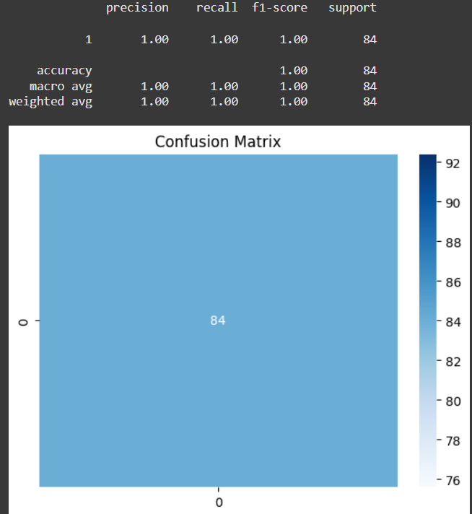

Confusion Matrix

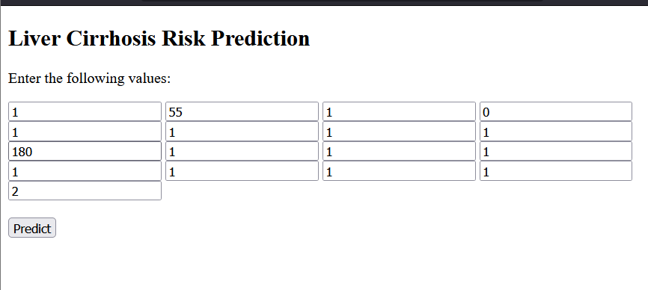

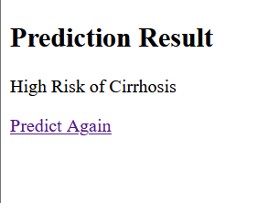

Flask UI prediction result

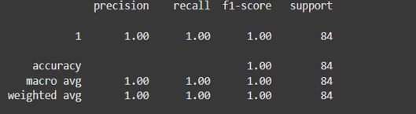

Training accuracy output

**Future Scope**

* Integration with hospital EHR systems for real-time prediction.
* Testing with larger, more diverse datasets.
* Addition of explainable AI to understand feature impact on predictions.

**Conclusion**

This project demonstrates the power of machine learning for early detection of liver cirrhosis, potentially aiding healthcare professionals in timely interventions and personalized treatment planning while optimizing healthcare resources.